Project Title: Sales Performance Analysis Dashboard
Business Domain: E-commerce
Tool Used: MySQL , MySQL workbench , PowerBI , numpy & pandas in python and Excel
Author: Sreeram Sandhya Rani

Dashboard

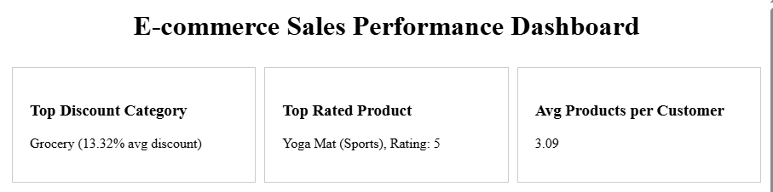
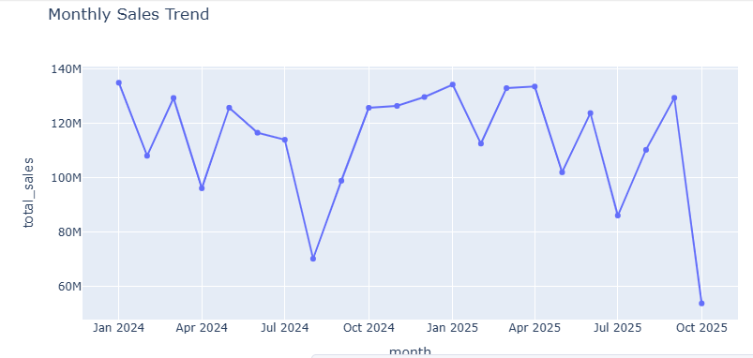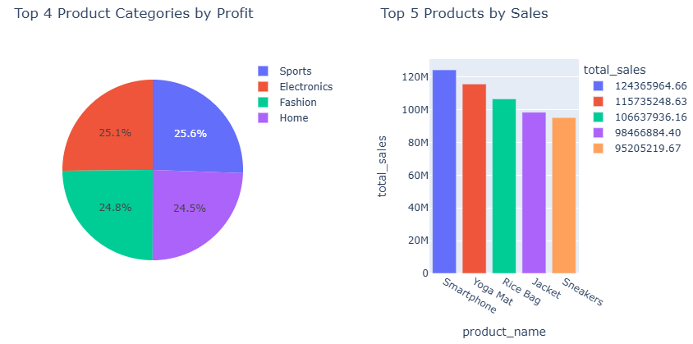
Overview:
This project aims to evaluate the sales performance of the organization by analysing key sales metrics, identifying performance patterns using modern tools .
Data extracted and structured using MySQL workbench , analysed and cleaned using python (MySQL connector , NumPy and Pandas), and visualized through interactive dashboards in Power BI.

Key Objectives:
- Extract and clean sales data from a MySQL database.
- Create call procedures and tables correlation in MySQL workbench.
- Use python Mysqlconnector to connect the data base and create a data frames .
- Use Python Pandas and NumPy to perform statistical and exploratory data analysis.
- Develop interactive dashboards in python using Xplots and Power BI for leadership insights.
- Identify key trends, correlations, and performance drivers.
- Provide strategic recommendations for improving sales revenue and efficiency.

Data cleaning and Extraction :
- Used MySQL workbench for connecting to the sales database or to create a database for the given CSV file
- Running SQL queries to extract tables and create a stored procedures with the help of table correlations .
- Performing joins, aggregations, and data validation
- Mainly created stored procedures are as below :
  - Top rated Product category
  - Average product per customer
  - Monthly sales trends
- Data cleaning performed using python NumPy and Pandas.

Metrics and Analysis :
  - Using python MySQL connector library connected to MySql data base for analysing the data .
  - Pandas for data cleaning and merging datasets
  - Numpy for numerical operations and statistical computations.
  - Created Data frames for the stored procedures and tables .

    - Avg products per customer
    - Get Monthly sales trend
    - Get sales insights
    - Get top discount category
    - Get top product category profits
    - Get top rated product
    - Get total revenue
    - Get yearly sales

  - Plotted the metrics for the below :

    - Pie chart : Top 4 product categories by profit

    - KPI cards : Top discount category , Top rated product ,

Average products per customer,

Column chat: Top 5 products by sales

Line chat: Monthly sales trend
Data visualization using Power BI :
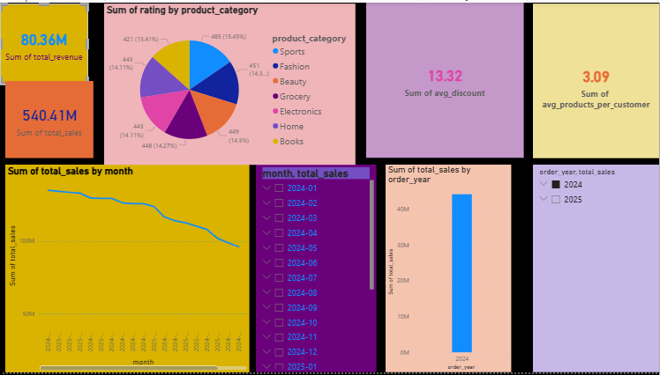

For more precise analysis, created dash board using Power BI .
Connected the data base by using MySQL database under get data > database > MySQL database in power BI.
Imported the stored procedures and loaded as Queries in power BI
Created the KPI cards, slicers, Bar charts and Line charts for the stored procedures .

Conclusion:
Through detailed analysis key sales metrics at the month of 2025 oct the sales are very low. Monthly sales trends and sales insights addressing the performance of sales and helping to take the strategic decisions.
With precise discount percentage for the less demand products will increase the sales of the product.
Aim to make the increase the Avg product per customer from 3 to 5
Workflows:
- What is the average number of products per customer?
- Which product generate the highest sales or profit?
- Which product category has the highest discount?
- Which product received the highest rating?
- Total Revenue : ---
- Total sales : -----
- What are the Monthly sales trends?
- What are the Yearly sales trends for products?

